**Transposition Cipher**

1. **RailFence:**

**Program:**

import java.util.Scanner;

public class rail {

int numRails;

public rail(int numRails) {

this.numRails = numRails;

}

String getDecryptedData(String data) {

char[] decrypted = new char[data.length()];

int n = 0;

for(int k = 0 ; k < numRails; k ++) {

int index = k;

boolean down = true;

while(index < data.length() ) {

//System.out.println(k + " " + index+ " "+ n );

decrypted[index] = data.charAt(n++);

if(k == 0 || k == numRails - 1) {

index = index + 2 * (numRails - 1);

}

else if(down) {

index = index + 2 * (numRails - k - 1);

down = !down;

}

else {

index = index + 2 * k;

down = !down;

}

}

}

return new String(decrypted);

}

String getEncryptedData(String data) {

char[] encrypted = new char[data.length()];

int n = 0;

for(int k = 0 ; k < numRails; k ++) {

int index = k;

boolean down = true;

while(index < data.length() ) {

//System.out.println(k + " " + index+ " "+ n );

encrypted[n++] = data.charAt(index);

if(k == 0 || k == numRails - 1) {

index = index + 2 * (numRails - 1);

}

else if(down) {

index = index + 2 * (numRails - k - 1);

down = !down;

}

else {

index = index + 2 * k;

down = !down;

}

}

}

return new String(encrypted);

}

public static void main(String[] args) {

Scanner scan =new Scanner(System.in);

System.out.println("Enter plain text:");

String data=scan.nextLine();

String str;

int i,a;

a = data.indexOf(" ");

str = data.replaceAll("\\s", "");

str = str.toLowerCase();

System.out.println("Enter no of rails:");

int n =scan.nextInt();

rail railFenceCipher = new rail(n);

String encrypted =railFenceCipher.getEncryptedData(str);

System.out.println("Encryption:"+encrypted);

String decrypted = railFenceCipher.getDecryptedData(encrypted);

System.out.println("Decryption:"+decrypted);

}

}

**Screenshot:**

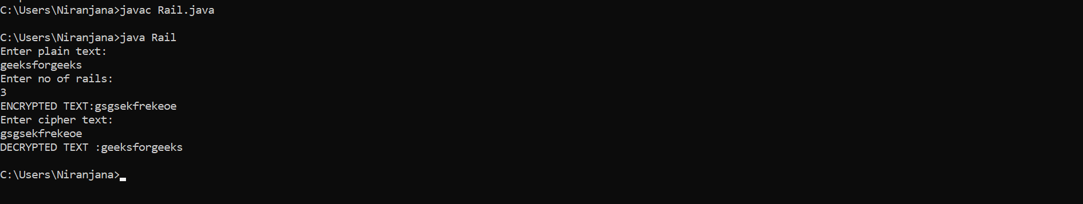

1. **Rowcolumn:**

**Program:**

import java.util.*;

public class row{

public static void main(String[] args) {

String s,str;

System.out.println("Enter The String:");

Scanner scan = new Scanner(System.in);

s=scan.nextLine();

str = s.replaceAll("\\s", "");

int row,col;

System.out.println("Enter No of Rows:");

row=scan.nextInt();

System.out.println("Enter No of Columns:");

col=scan.nextInt();

char[][] mat = new char[row][col];

int i,j,k=0,c=120;

for(i=0;i<row;i++)

for(j=0;j<col;j++){

if(k<str.length())

{

mat[i][j]=str.charAt(k++);

}

else

{

mat[i][j]=(char)c;

c++;

}

}

for(i=0;i<row;i++){

for(j=0;j<col;j++){

System.out.print(mat[i][j]);

System.out.print(" ");

}

System.out.println("\n");

}

int[] key = new int[col];

System.out.println("Enter Key String");

for(i=0;i<col;i++){

key[i]=scan.nextInt();

}

System.out.println("Encrypted Text:");

for(i=0;i<col;i++){

for(j=0;j<row;j++){

System.out.print(mat[j][key[i]-1]);

}

}

}

}

**Screenshot:**

